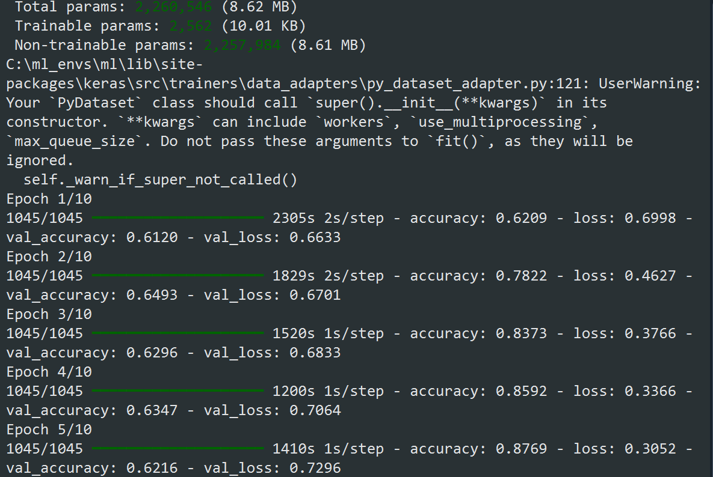

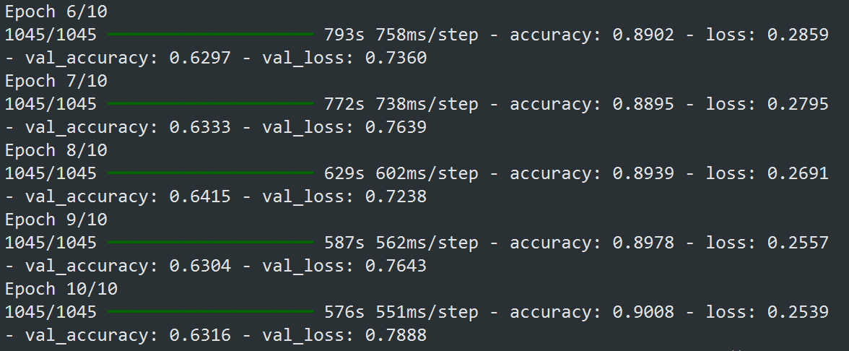

runfile('C:/Users/anasa/Downloads/DriverDrowsinessDetection/train_model.py', wdir='C:/Users/anasa/Downloads/DriverDrowsinessDetection')

Found 33435 images belonging to 2 classes.

Found 8358 images belonging to 2 classes.

الكلاسات المكتشفة: {'Drowsy': 0, 'NonDrowsy': 1}

عدد الفئات: 2

Model: "sequential"

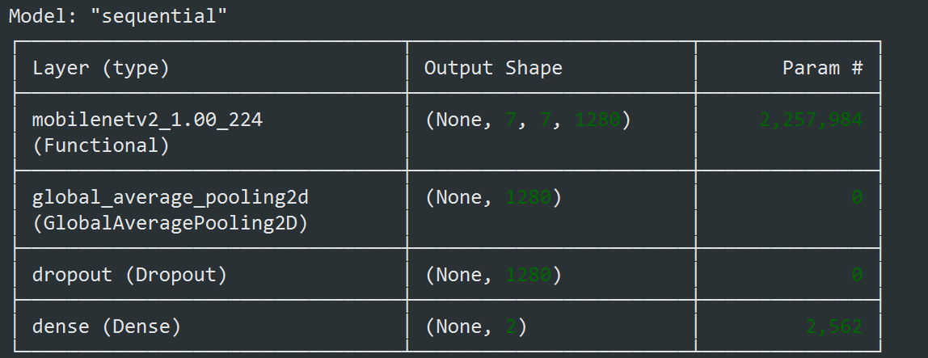

Total params: 2,260,546 (8.62 MB)

Trainable params: 2,562 (10.01 KB)

Non-trainable params: 2,257,984 (8.61 MB)

C:\ml_envs\ml\lib\site-packages\keras\src\trainers\data_adapters\py_dataset_adapter.py:121: UserWarning: Your `PyDataset` class should call `super().__init__(**kwargs)` in its constructor. `**kwargs` can include `workers`, `use_multiprocessing`, `max_queue_size`. Do not pass these arguments to `fit()`, as they will be ignored.

self._warn_if_super_not_called()

Epoch 1/10

1045/1045 ━━━━━━━━━━━━━━━━━━━━ 2305s 2s/step - accuracy: 0.6209 - loss: 0.6998 - val_accuracy: 0.6120 - val_loss: 0.6633

Epoch 2/10

1045/1045 ━━━━━━━━━━━━━━━━━━━━ 1829s 2s/step - accuracy: 0.7822 - loss: 0.4627 - val_accuracy: 0.6493 - val_loss: 0.6701

Epoch 3/10

1045/1045 ━━━━━━━━━━━━━━━━━━━━ 1520s 1s/step - accuracy: 0.8373 - loss: 0.3766 - val_accuracy: 0.6296 - val_loss: 0.6833

Epoch 4/10

1045/1045 ━━━━━━━━━━━━━━━━━━━━ 1200s 1s/step - accuracy: 0.8592 - loss: 0.3366 - val_accuracy: 0.6347 - val_loss: 0.7064

Epoch 5/10

1045/1045 ━━━━━━━━━━━━━━━━━━━━ 1410s 1s/step - accuracy: 0.8769 - loss: 0.3052 - val_accuracy: 0.6216 - val_loss: 0.7296

Epoch 6/10

1045/1045 ━━━━━━━━━━━━━━━━━━━━ 793s 758ms/step - accuracy: 0.8902 - loss: 0.2859 - val_accuracy: 0.6297 - val_loss: 0.7360

Epoch 7/10

1045/1045 ━━━━━━━━━━━━━━━━━━━━ 772s 738ms/step - accuracy: 0.8895 - loss: 0.2795 - val_accuracy: 0.6333 - val_loss: 0.7639

Epoch 8/10

1045/1045 ━━━━━━━━━━━━━━━━━━━━ 629s 602ms/step - accuracy: 0.8939 - loss: 0.2691 - val_accuracy: 0.6415 - val_loss: 0.7238

Epoch 9/10

1045/1045 ━━━━━━━━━━━━━━━━━━━━ 587s 562ms/step - accuracy: 0.8978 - loss: 0.2557 - val_accuracy: 0.6304 - val_loss: 0.7643

Epoch 10/10

1045/1045 ━━━━━━━━━━━━━━━━━━━━ 576s 551ms/step - accuracy: 0.9008 - loss: 0.2539 - val_accuracy: 0.6316 - val_loss: 0.7888

WARNING:absl:You are saving your model as an HDF5 file via `model.save()` or `keras.saving.save_model(model)`. This file format is considered legacy. We recommend using instead the native Keras format, e.g. `model.save('my_model.keras')` or `keras.saving.save_model(model, 'my_model.keras')`.

تم حفظ النموذج كـ trained_model.h5

2025-06-21 00:10:01.791573: I tensorflow/core/platform/cpu_feature_guard.cc:210] This TensorFlow binary is optimized to use available CPU instructions in performance-critical operations.

To enable the following instructions: SSE3 SSE4.1 SSE4.2 AVX AVX2 AVX512F AVX512_VNNI FMA, in other operations, rebuild TensorFlow with the appropriate compiler flags.

